# FINAL EXAMINATION (2024-2025)

**UKG**

**General Awareness**

# **Total Time: 3 hours Total Marks: 50**

General Instructions.

• All questions are compulsory.

• Marks of each question are indicated against it.

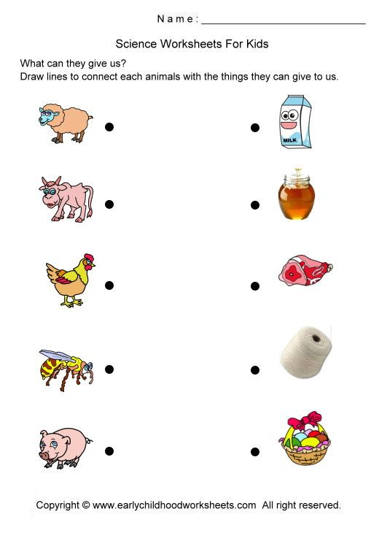A. Identify and match the animals to the things they give us. (5x1=5)

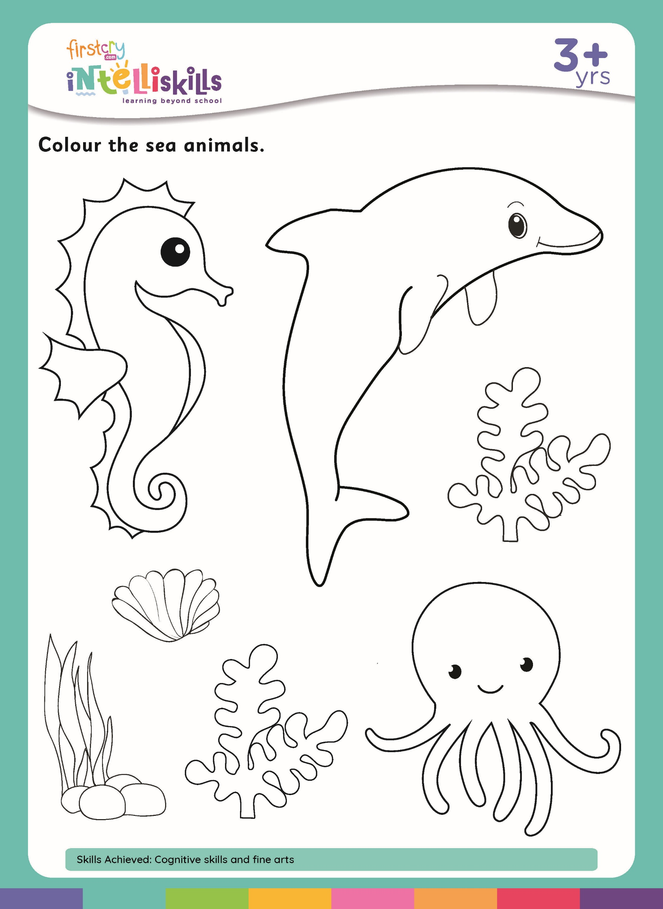B. Color any three sea animal (3x2=6)

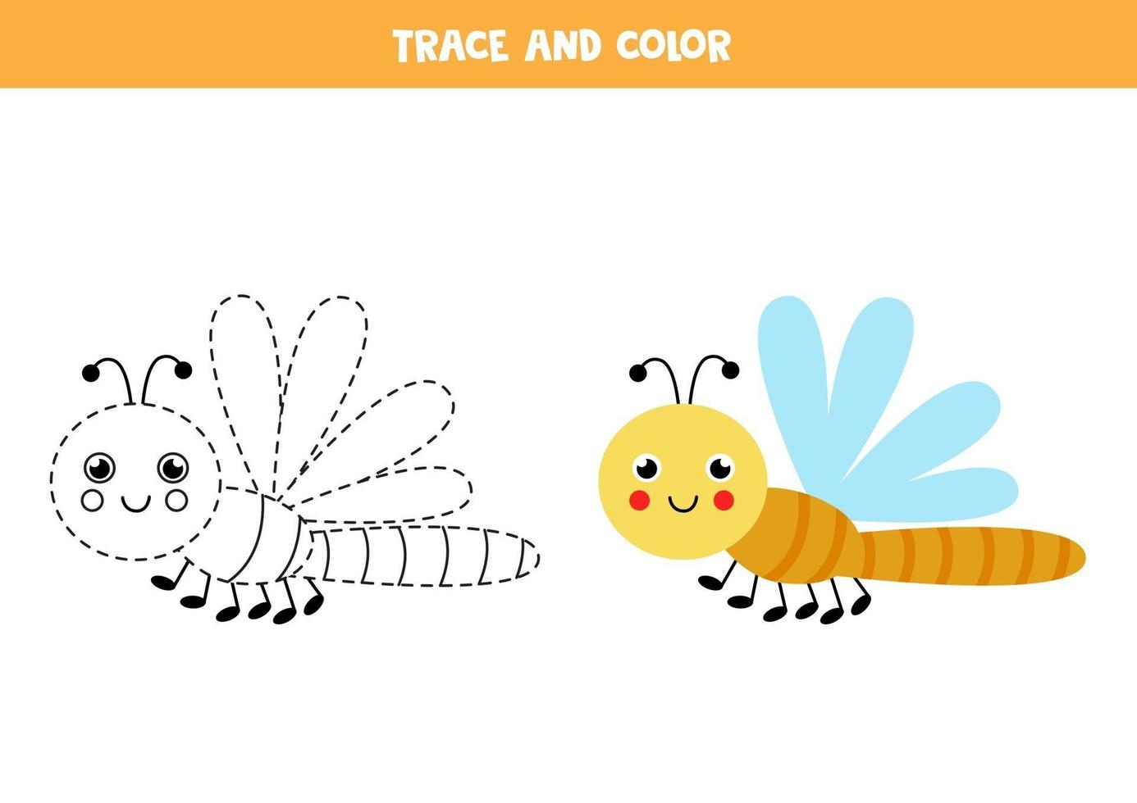C. Trace and color the insect. (5)

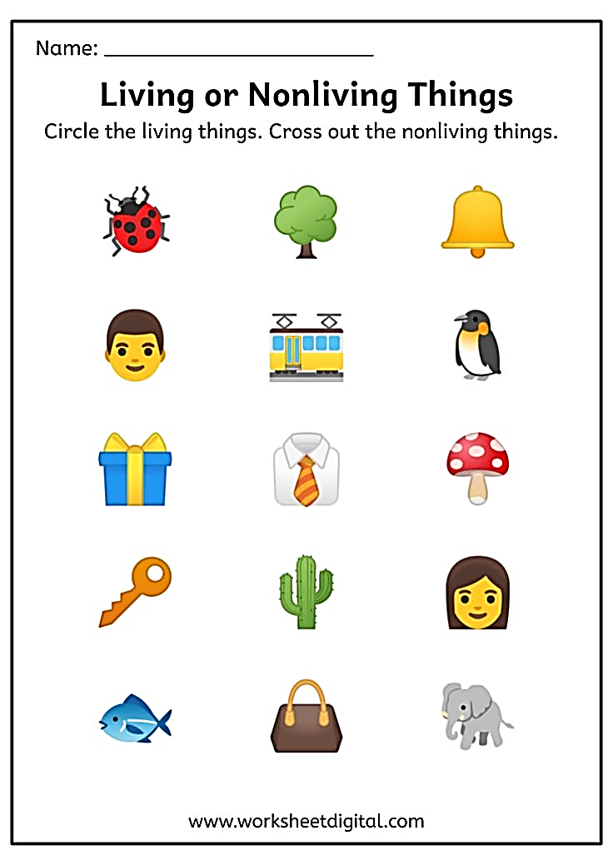D. Circle the living things. Cross out nonliving things. (9x1=9)

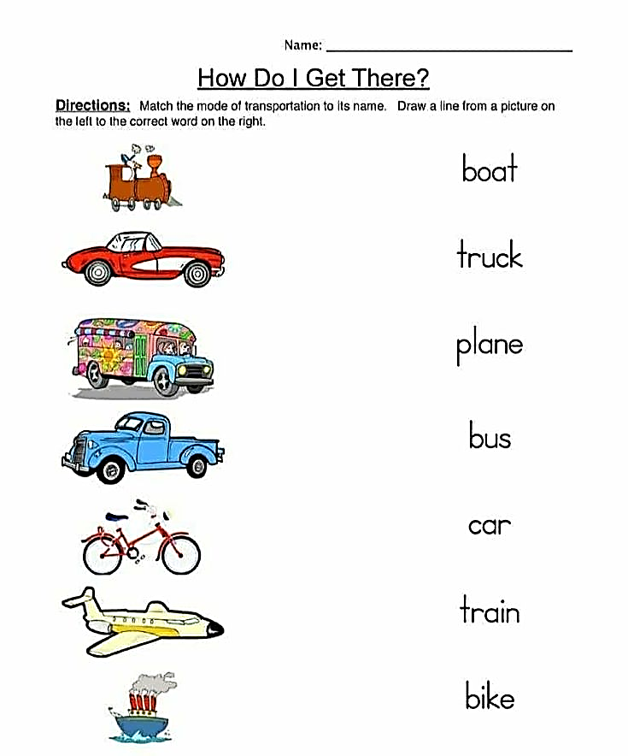E. Match the vechicle name with their picture (7x1=7)

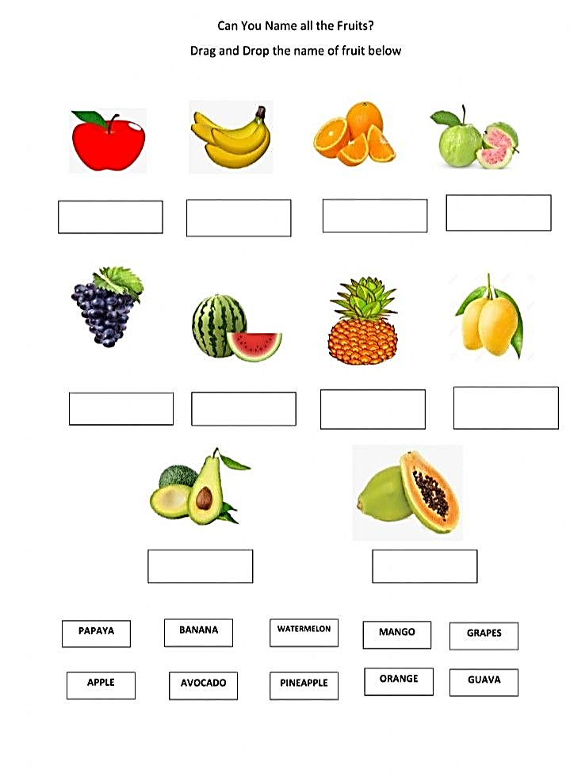F. Write thr Fruit name and circle our national fruit (2x2=4)

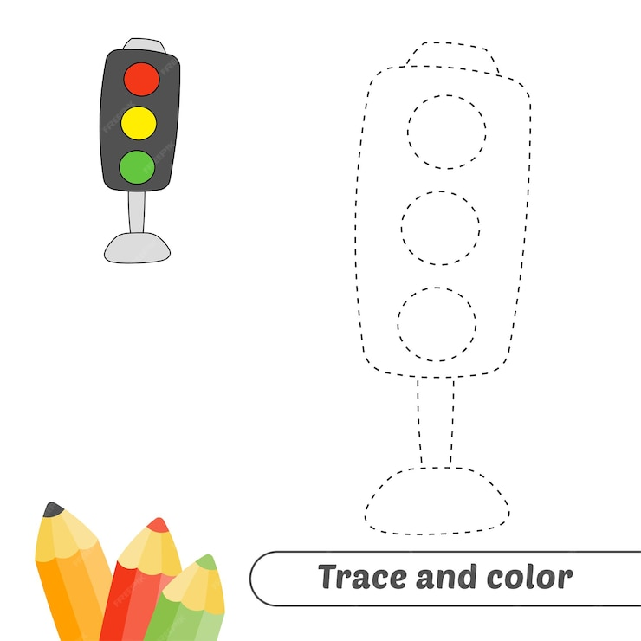 G. Trace and color the Traffic Light . (6)

H. Match the festival to their pictures (4x2=8)

