

**RPPS BOKARO**

**Set- C**

**Summer Holiday Homework (Session 2025-26)**

**Class – VI**

**\*\*\*\*\*\*\*\*\*\*\*\*\*\*\*\*\*\*\*\*\*\*\*\*\*\*\*\*\*\*\*\*\*\*\*\*\*\*\*\*\*\*\*\*\*\*\*\*\*\*\*\*\*\*\*\*\*\*\*\*\*\*\*\*\*\*\*\*\*\*\***

**SUBJECT – S.st**

1) Draw the picture of globe and label it. (Page no-15)

2) Show Ancient and modern city on the map. (Page no-18)

3) Write the different types of Sources of History. Do it in chart paper. (Page no-67)

4) Make a list of all people outside your family that are supporting you through their work in one way or

another.

5) Write and learn question answer of ch-2, 4 and 9.

**Note - Do all these questions in A4 size paper and gather it in a stick file.**

**\*\*\*\*\*\*\*\*\*\*\*\*\*\*\*\*\*\*\*\*\*\*\*\*\*\*\*\*\*\*\*\*\*\*\*\*\*\*\*\*\*\*\*\*\*\*\*\*\*\*\*\*\*\*\*\*\*\*\*\*\*\*\*\*\*\*\*\*\*\*\***

**SUBJECT – ENGLISH**

**1. Write 50 words with one synonym for each scrapbook or A4 sized chart paper**

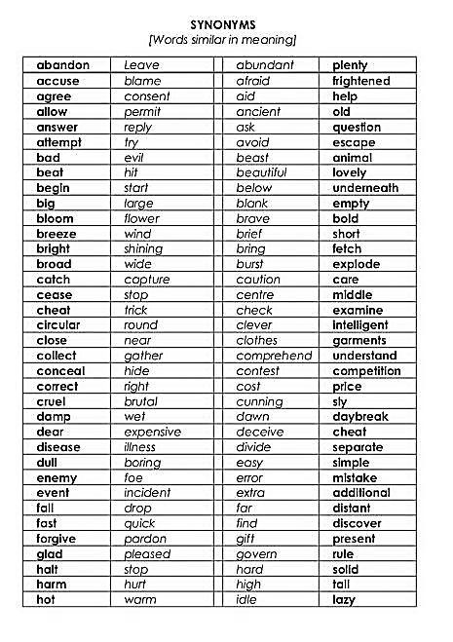Eg —-

2**. Fill a jar / any containers with new/interesting/hard words. You will learn during the holidays or**

**from your text book, written in small pieces of paper**

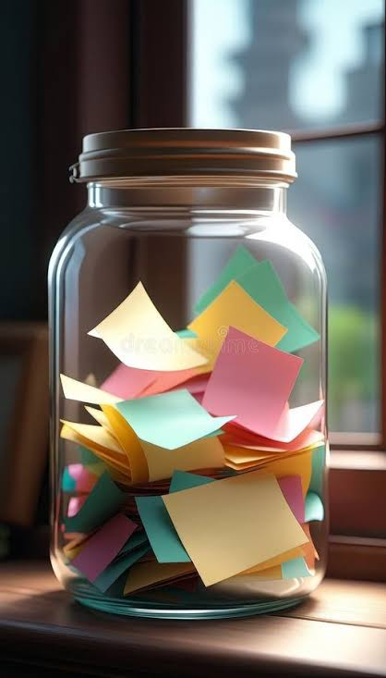

**Also write the meanings or draw small illustrations or doodles supporting the word on the same piece of paper as the word**

**3. Thoroughly learn the poem what a bird thought from page 86 of your English textbooks.**

**\*\*\*\*\*\*\*\*\*\*\*\*\*\*\*\*\*\*\*\*\*\*\*\*\*\*\*\*\*\*\*\*\*\*\*\*\*\*\*\*\*\*\*\*\*\*\*\*\*\*\*\*\*\*\*\*\*\*\*\*\*\*\*\*\*\*\*\*\*\*\***

**SUBJECT –SCIENCE**

**1. Make a scale/ ruler of 50 cm using a cardboard, pencil, marker etc**

**For accurate measurements used regular 15 cm or 30 cm rulers**

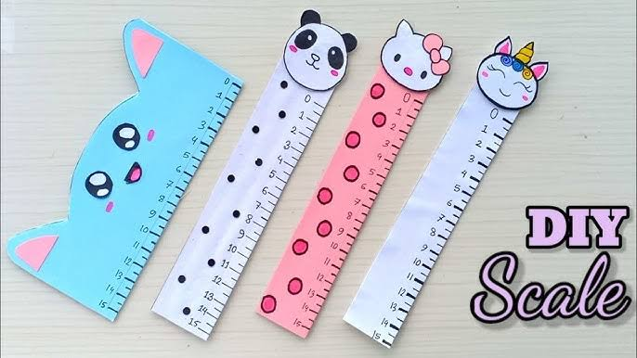

**Eg**

**2. Create a poster on a big chart paper or scrapbook (using 2 pages) showing the classification of plants and animals, also that diversity based on habitat / climate. ( Eg - herbs, shrubs , desert animals , aquatic animals etc)**

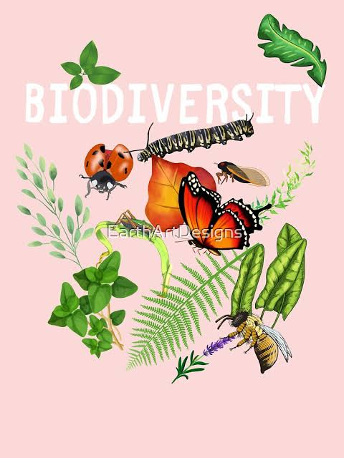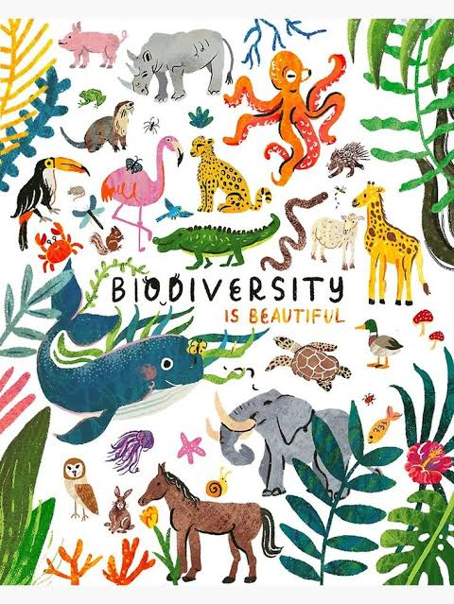

**3. Create a timeline of evolution of transport (include illustrations and brief descriptions of each )**

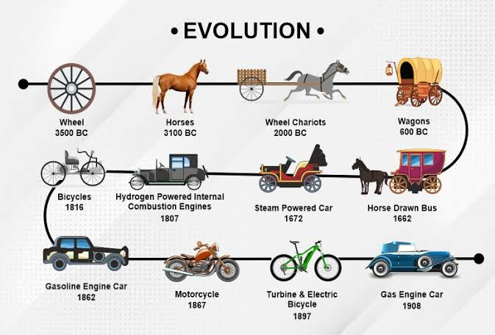

**Eg**

**.**

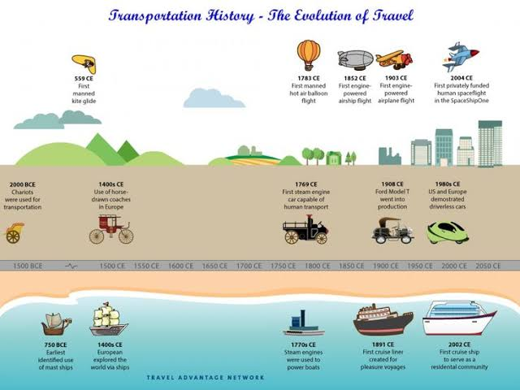

**\*\*\*\*\*\*\*\*\*\*\*\*\*\*\*\*\*\*\*\*\*\*\*\*\*\*\*\*\*\*\*\*\*\*\*\*\*\*\*\*\*\*\*\*\*\*\*\*\*\*\*\*\*\*\*\*\*\*\*\*\*\*\*\*\*\*\*\*\*\*\***

**SUBJECT –MATH’S**

1. **MATHS ASSIGNMENTS:-**
2. **Numbers systems**
3. **Measurement models**
4. **Fractions**
5. **MATHS BOOK :- Table -2 to 20**

**Learn it**

1. **Ex. – 3.1 to 3.3**

**Do in your math’s copy**

**\*\*\*\*\*\*\*\*\*\*\*\*\*\*\*\*\*\*\*\*\*\*\*\*\*\*\*\*\*\*\*\*\*\*\*\*\*\*\*\*\*\*\*\*\*\*\*\*\*\*\*\*\*\*\*\*\*\*\*\*\*\*\*\*\*\*\*\*\*\*\***

**SUBJECT – HINDI**

1. **कविता याद करें।**
2. **हर दिन एक सुलेख लिखें।**
3. **अभ्यास पुस्तिका पृष्ठ संख्या– 5,6(उत्तर दो-क से च तक)**
4. **अभ्यास पुस्तिका पृष्ठ संख्या-16 (उत्तर दो- क से च तक)**
5. **व्याकरण (पत्र) पृष्ठ संख्या- 180 का 2 ,184 का 4**
6. **सोहनलाल द्विवेदी और ध्यानचंद का चित्र चार्ट पेपर में बनावें और उनके जीवन परिचय लिखें।**

**\*\*\*\*\*\*\*\*\*\*\*\*\*\*\*\*\*\*\*\*\*\*\*\*\*\*\*\*\*\*\*\*\*\*\*\*\*\*\*\*\*\*\*\*\*\*\*\*\*\*\*\*\*\*\*\*\*\*\*\*\*\*\*\*\*\*\*\*\*\*\***

**SUBJECT – SANSKRIT**

1. **निम्नलिखितशब्दानामं वर्ण वियोग कुरुत।**

**क. विद्या- च. प्रगति-**

**ख. क्षत्रिय- छ. ध्वनि-**

**ग. कार्यम्- ज. सरस्वती-**

**घ.सृष्टि- झ. वाक्यम्**

**ङ. प्रातःकाल - ञ. क्रीडा-**

**2. पाठ 2 ( अभ्यास कार्य 1, 2, 4, 5 ,6 ,7 ,8)**

**3. पृष्ठ संख्या - 29, 30, 31, 32**

**\*\*\*\*\*\*\*\*\*\*\*\*\*\*\*\*\*\*\*\*\*\*\*\*\*\*\*\*\*\*\*\*\*\*\*\*\*\*\*\*\*\*\*\*\*\*\*\*\*\*\*\*\*\*\*\*\*\*\*\*\*\*\*\*\*\*\*\*\*\*\***

**SUBJECT – COMPUTER**

1. Make flowchart of types of computer language in A4 size chart paper.

2. On a big size of chart paper draw social networking do's and don'ts.

3. Make arithmetic operator table in A4 size chart paper.

4. Learn question answer of chapter 1

5. Read chapter 2 and 3

**\*\*\*\*\*\*\*\*\*\*\*\*\*\*\*\*\*\*\*\*\*\*\*\*\*\*\*\*\*\*\*\*\*\*\*\*\*\*\*\*\*\*\*\*\*\*\*\*\*\*\*\*\*\*\*\*\*\*\*\*\*\*\*\*\*\*\*\*\*\*\***

**SUBJECT – G.K.**

**Topic strange insects**

**A. Collect and paste strange insects below each fact about it.**

**1) Australian tiger beetle**

**2) Honey bee**

**3) black widow spider**

**4) spiting spider**

**Note…. You may use printed image or draw them if you like.**

**B) page no -5 venomous plants**

**With the name draw the picture in scrapbook.**

**C) collect 5 spices pack it in small packet then past it in scrapbook and write their name**

**4) Past the picture of reptile and write about them in G.k copy book page number 8.**