

**RPPS BOKARO**

**Set- C**

**Summer Holiday Homework (Session 2025-26)**

**Class – V**

**\*\*\*\*\*\*\*\*\*\*\*\*\*\*\*\*\*\*\*\*\*\*\*\*\*\*\*\*\*\*\*\*\*\*\*\*\*\*\*\*\*\*\*\*\*\*\*\*\*\*\*\*\*\*\*\*\*\*\*\*\*\*\*\*\*\*\*\*\*\*\***

**SUBJECT - E.V.S**

1) Paste 10 pictures of different types of games. (5 outdoor game. 5 indoor game)

2) Draw the diagram of the human respiratory system and label them

3) Paste 10 pictures of helper’s name and write 2 Lines about them.

4) Make family tree of your family member by pasting their pictures.

5) Draw the different symbol to show that place or facility can be used by differently abled (Page no-10)

6) write and learn question answer of 1 to 4.

**Note - Do all these homework in A4 size paper and gather it in stick file.**

**\*\*\*\*\*\*\*\*\*\*\*\*\*\*\*\*\*\*\*\*\*\*\*\*\*\*\*\*\*\*\*\*\*\*\*\*\*\*\*\*\*\*\*\*\*\*\*\*\*\*\*\*\*\*\*\*\*\*\*\*\*\*\*\*\*\*\*\*\*\*\***

**SUBJECT - ENGLISH**

**1.Write the names of 10 English writers and the names of two books / stories / poems written by**

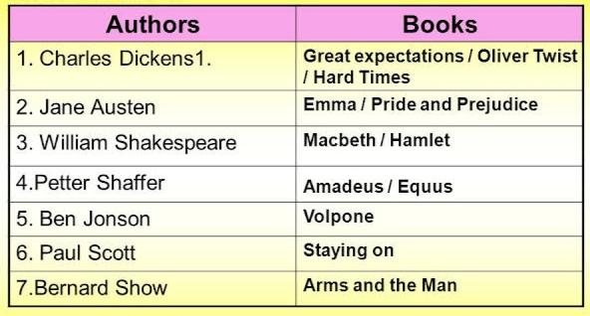 **them**

Eg

**2. Write a short story in 20 lines on any one of the following topics. Do it in your scrapbook or an**

**A4 sized chart paper.**

1. Most memorable summer vacation you have had
2. A trip to your favourite place
3. 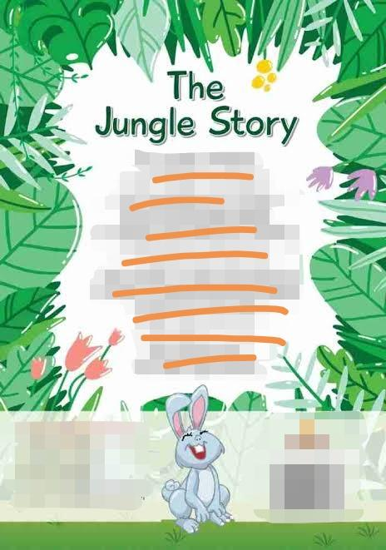A Jungle story

Eg

**Also draw a beautiful cover picture for your story in your scrapbook or and A4 size chart**

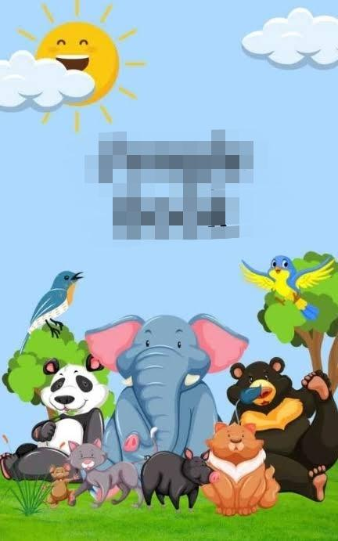 **paper.**

Eg

1. **Learn the poem “From a Railway Carriage “(page 38) from your textbooks.**

**\*\*\*\*\*\*\*\*\*\*\*\*\*\*\*\*\*\*\*\*\*\*\*\*\*\*\*\*\*\*\*\*\*\*\*\*\*\*\*\*\*\*\*\*\*\*\*\*\*\*\*\*\*\*\*\*\*\*\*\*\*\*\*\*\*\*\*\*\*\*\***

**SUBJECT – MATH’S**

1. **MATHS ASSIGNMENT :-**
2. **Months of the year**
3. **Place – value chart**
4. **Roman numbers with ice-cream sticks**
5. **MATHS BOOK :- Page no. -38 to 41**

**Ex.- 3.1 to 3.3**

**Do in your maths copy**

**\*\*\*\*\*\*\*\*\*\*\*\*\*\*\*\*\*\*\*\*\*\*\*\*\*\*\*\*\*\*\*\*\*\*\*\*\*\*\*\*\*\*\*\*\*\*\*\*\*\*\*\*\*\*\*\*\*\*\*\*\*\*\*\*\*\*\*\*\*\*\***

**SUBJECT – HINDI**

1. **कविता याद करें।**
2. **हर दिन एक सुलेख लिखें।**
3. **अभ्यास पुस्तिका पृष्ठ संख्या-6,7(उत्तर दो क से ड तक)**
4. **अभ्यास पुस्तिका पृष्ठ संख्या-14 (उत्तर दो क से झ तक)**
5. **व्याकरण (पत्र) पृष्ठ संख्या- 148- 1**

**\*\*\*\*\*\*\*\*\*\*\*\*\*\*\*\*\*\*\*\*\*\*\*\*\*\*\*\*\*\*\*\*\*\*\*\*\*\*\*\*\*\*\*\*\*\*\*\*\*\*\*\*\*\*\*\*\*\*\*\*\*\*\*\*\*\*\*\*\*\*\***

**SUBJECT – SANSKRIT**

1. **दिवसानाम् नामानि (पृष्ठ- 41)**
2. **तरूणाम् नामानि ( पृष्ठ -41)**
3. **सूक्तय: - 1,2, 3 (पृष्ठ-48)**
4. **शब्दकोश: (पृष्ठ - 49,50)**

**SUBJECT - COMPUTER**

1. On a big size chart paper make evolution of computer along with years (page 34 and 35).

2. Draw picture of control panel in your notebook

3. Read chapter 1 and 2

4. Learn question answer of chapter 1

**\*\*\*\*\*\*\*\*\*\*\*\*\*\*\*\*\*\*\*\*\*\*\*\*\*\*\*\*\*\*\*\*\*\*\*\*\*\*\*\*\*\*\*\*\*\*\*\*\*\*\*\*\*\*\*\*\*\*\*\*\*\*\*\*\*\*\*\*\*\*\***

**SUBJECT – G.K.**

**1.Paste the pictures of the following in your scrapbook / A4 sized chart papers**

1. **5 medicinal plants**
2. **5 wild animals**
3. **5 domestic animals**
4. **5 Aquatic animals**
5. **5 adventurous quotes**