**RPPS BOKARO**

**Set- C**

**Summer Holiday Homework (Session 2025-26)**

**Class – IV**

**\*\*\*\*\*\*\*\*\*\*\*\*\*\*\*\*\*\*\*\*\*\*\*\*\*\*\*\*\*\*\*\*\*\*\*\*\*\*\*\*\*\*\*\*\*\*\*\*\*\*\*\*\*\*\*\*\*\*\*\*\*\*\*\*\*\*\*\*\*\*\***

**SUBJECT - EVS**

1) Prepare a chart showing mammals and their young. write their name.

2) Paste 10 pictures of Helpers name and their work

3) Paste the 5 picture of Bad touch and 5 picture 3 of good touch.

4) Draw and colour the picture of Sense organ and write about them.

5) Paste 5 picture of indoor game and paste 5 pictures of outdoor game and name it.

6) Draw or paste 10 festivals of different states

7) Write an essay on any one family member who influenced you the most and is your role model.

8) learn questions answers. Ch 1 to 4

**\*\*\*\*\*\*\*\*\*\*\*\*\*\*\*\*\*\*\*\*\*\*\*\*\*\*\*\*\*\*\*\*\*\*\*\*\*\*\*\*\*\*\*\*\*\*\*\*\*\*\*\*\*\*\*\*\*\*\*\*\*\*\*\*\*\*\*\*\*\*\***

**SUBJECT - ENGLISH**

1. **Write 50 words with their synonyms, from your English copies. Do it in your scrapbook / an A4 sized chart paper**.
2. Large 6.True 11.Exit 16.Present 21. Alike
3. Stone 7.Last 12.Easy 17. False 22. Above
4. Difficult 8.Write 13.Mistake 18. Occur 23. Trip
5. Sad 9.Job 14.Infant 19.Always 24. ast
6. Ill 10.Safe 15.Rich 20. Old 25.One

**2. Create and write down a short story on any one of these topics in at least 10 lines** . **Do it in**

**your scrapbook or an A4 sized chart paper .**

a) your most memorable summer vacation

b) a trip to your favourite place

c) a Jungle story

**Also make a cover picture for your story**

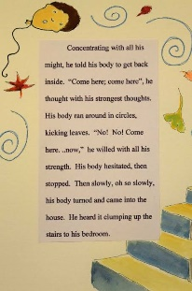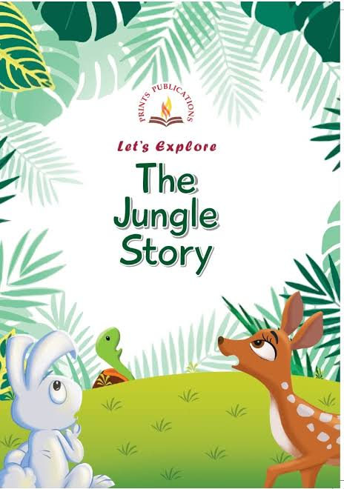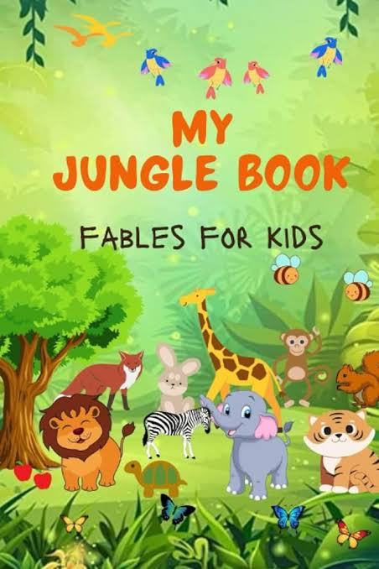 **Eg -**

**3. Learn the poem THE VIOLETS from (page 64) of your English textbooks.**

**SUBJECT – G.K**

1. **Write the five symbolic birds name and past the picture in scrapbook.**
2. **Write the oldest trees on the Earth and past the picture in the.**
3. **Write the aquatic animal's name and past the picture in scrapbook.**

**Excise 7 and 8 do in G.k copy**

**\*\*\*\*\*\*\*\*\*\*\*\*\*\*\*\*\*\*\*\*\*\*\*\*\*\*\*\*\*\*\*\*\*\*\*\*\*\*\*\*\*\*\*\*\*\*\*\*\*\*\*\*\*\*\*\*\*\*\*\*\*\*\*\*\*\*\*\*\*\*\***

**SUBJECT – MATH’S**

1. **MATHS SCRAPEBOOK ASSIGNMENT: -.**
2. **Roman numbers with matchstick or ice-cream stick in your scrapbook number: - (1 to 50)**
3. **Days of a week**
4. **Fine shapes names**
5. **Place value chart**

**\*\*\*\*\*\*\*\*\*\*\*\*\*\*\*\*\*\*\*\*\*\*\*\*\*\*\*\*\*\*\*\*\*\*\*\*\*\*\*\*\*\*\*\*\*\*\*\*\*\*\*\*\*\*\*\*\*\*\*\*\*\*\*\*\*\*\*\*\*\*\***

**SUBJECT – HINDI**

1. **कविता याद करें।**
2. **हर दिन एक सुलेख लिखें।**
3. **बादलों के चित्र बनाइए।(काले -काले डरावने, गुब्बारे- से गालों वाले, हल्के -फुल्के सुहाने)**
4. **अभ्यास पुस्तिका पृष्ठ संख्या- 12 (उत्तर दो- क से ढ तक)**
5. **अभ्यास पुस्तिका पृष्ठ संख्या 19 (उत्तर दो- क से ड तक)**
6. **पर्यायवाची शब्द लिखें। (चार्ट पेपर में और याद करें)**

**\*\*\*\*\*\*\*\*\*\*\*\*\*\*\*\*\*\*\*\*\*\*\*\*\*\*\*\*\*\*\*\*\*\*\*\*\*\*\*\*\*\*\*\*\*\*\*\*\*\*\*\*\*\*\*\*\*\*\*\*\*\*\*\*\*\*\*\*\*\*\***

**SUBJECT – COMPUTER**

1. Paste different pictures of primary memory and secondary memory in scrap book.

2. In your scrapbook book write measuring the computers memory from chapter 1.

3. Read chapter 3 and 4

4. Learn exercise of chapter 1