 **RPPS BOKARO**

**Set- A**

**Summer Holiday Homework (Session 2025-26)**

**Class – VII**

**\*\*\*\*\*\*\*\*\*\*\*\*\*\*\*\*\*\*\*\*\*\*\*\*\*\*\*\*\*\*\*\*\*\*\*\*\*\*\*\*\*\*\*\*\*\*\*\*\*\*\*\*\*\*\*\*\*\*\*\*\*\*\*\*\*\*\*\*\*\*\***

**Subject - Hindi**

1.निम्नलिखित बिंदुओं के आधार पर ‘**शाम एक किसान’** विषय पर एक प्ररियोजना तैयार करें।

*विद्यालय का नाम और विद्यार्थी का परिचय

*अभिस्वीकृति *प्रमाण पत्र *अनुक्रमणिका *कवि का चित्र*,कवि परिचय *कविता- शाम एक किसान सचित्र

*कविता का अर्थ

2.किन्हीं दो स्वतंत्रता सेनानियों के चित्र बनाकर उनके बारे में 10 10 पंक्तियां लिखें.।

**3.हिमालय पर्वत** विषय पर अनुच्छेद लिखें।

1. 10 पेज सुलेख लिखें।

**5**.व्याकरण (याद करें और लिखें)

* + 20 पर्यायवाची ( शैली- पृष्ठ संख्या 34)
  + 40 विलोम शब्द (शैली- पृष्ठ संख्या 37-38)
  + 20 अनेक शब्दों के लिए एक शब्द (शैली- पृष्ठ संख्या 37---38)

**6**.अभ्यास पुस्तिका ( पृष्ठ संख्या 22 23 24 25 और 26

**\*\*\*\*\*\*\*\*\*\*\*\*\*\*\*\*\*\*\*\*\*\*\*\*\*\*\*\*\*\*\*\*\*\*\*\*\*\*\*\*\*\*\*\*\*\*\*\*\*\*\*\*\*\*\*\*\*\*\*\*\*\*\*\*\*\*\*\*\*\*\***

**Subject – S.st**

1. Name the forest sphere of the earth.
2. What is atmosphere?
3. What is what hydrosphere comprises of ?
4. How is environment important to us?
5. What is archives?
6. What were called Nadu?
7. Scrapbook work :- structure of the earth

**\*\*\*\*\*\*\*\*\*\*\*\*\*\*\*\*\*\*\*\*\*\*\*\*\*\*\*\*\*\*\*\*\*\*\*\*\*\*\*\*\*\*\*\*\*\*\*\*\*\*\*\*\*\*\*\*\*\*\*\*\*\*\*\*\*\*\*\*\*\*\***

**Subject -Math’s**

**CH.1 - Integers NCERT/ R.S. Agrawal**

**CH.2- Fractions and Decimals NCERT/ R.S Agrawal**

**CH.3 - Data handling NCERT / R.S Agrawal**

**CH. 4 - Rational numbers NCERT/ R.S Aggarwal**

**Subject -English**

**1.Make a chart of 20-20 nouns on the big chart paper .**

**2.Write the summary of the poem in your notebook .**

**3.Pick out verb words from chapter 1 & 2 and write the verb forms of V2 and V3**

**4.Paste 10 Players in your notebook and write their name.**

**5.Write the paragraphs on "The value of education"**

**6.How you spend your vacation.**

**\*\*\*\*\*\*\*\*\*\*\*\*\*\*\*\*\*\*\*\*\*\*\*\*\*\*\*\*\*\*\*\*\*\*\*\*\*\*\*\*\*\*\*\*\*\*\*\*\*\*\*\*\*\*\*\*\*\*\*\*\*\*\*\*\*\*\*\*\*\*\***

**Subject -Science**

**Section -A Biology**

1 . Make a biodegradable pot by using waste cardboard and decorate it.

2 .Paste the picture of any five insectivorous plant and write their name.

3 Paste the picture of any five parasitic plant with their name.

4. Draw and label a picture of stomata on a chart paper with beautiful decoration.

5. Make model of human digestive system with the help of cardboard and label the l organ.

Section - B

6) Make a model of sundial. Explain its working.

7) If two trains start from a station and travel in opposite direction at speed of 10 km per hour and 15 km per hour respectively, how far apart will they be after 2 hours?

8) Write the name of 20 elements and their symbols with the help of periodic table

9) Make a chart of five organic acids and their sources.

Also write names of three strong acid and strong base.

**\*\*\*\*\*\*\*\*\*\*\*\*\*\*\*\*\*\*\*\*\*\*\*\*\*\*\*\*\*\*\*\*\*\*\*\*\*\*\*\*\*\*\*\*\*\*\*\*\*\*\*\*\*\*\*\*\*\*\*\*\*\*\*\*\*\*\*\*\*\*\***

**Subject -Computer**

1. Make a internal question from the chapter 1 and 2 yourself minimum 20 maximum as much as you can from each chapter with answer in a separate notebook.
2. Make a (Chart any one)

* Different types of Number system with its feature and example
* Binary Addition and Subtraction Rule
* Different types of charts in excel
* All the Elements of charts in excel

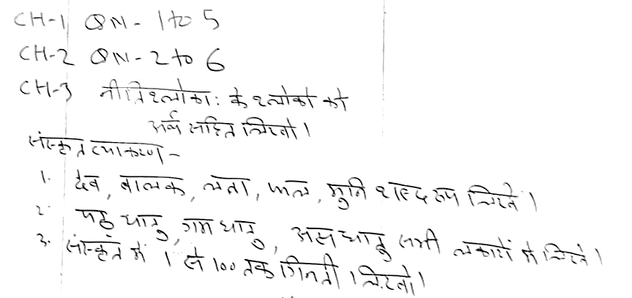**Subject -Sanskrit**