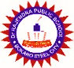 **RPPS BOKARO**

**Set- A**

**Summer Holiday Homework (Session 2025-26)**

**Class – VIII**

**\*\*\*\*\*\*\*\*\*\*\*\*\*\*\*\*\*\*\*\*\*\*\*\*\*\*\*\*\*\*\*\*\*\*\*\*\*\*\*\*\*\*\*\*\*\*\*\*\*\*\*\*\*\*\*\*\*\*\*\*\*\*\*\*\*\*\*\*\*\*\***

**Subject - Hindi**

1. निम्नलिखित बिंदुओं के आधार पर **भगवान के डाकिए’** विषय पर एक परियोजना तैयार करें।

*विद्यालय का नाम और विद्यार्थी का परिचय

*अभिस्वीकृति *प्रमाण पत्र *कविता (सचित्र) *कवि का चित्र

*कवि परिचय *कविता का अर्थ

2. ‘**सविनय अवज्ञा आंदोलन’ प**र अनुच्छेद लिखें।

3. व्याकरण (याद करें और लिखें)

*30 **पर्यायवाची शब्द** (शैली- पृष्ठ संख्या 35-36)

*50 **विलोम शब्द** (शैली पृष्ठ संख्या 39-40)

*30 **अनेक शब्दों के लिए एक शब्द** (शायरी पृष्ठ संख्या 43 44)

*10 **समूहवाची शब्द (**पृष्ठ संख्या 52)

4 अभ्यास पुस्तिका-पृष्ठ संख्या 30 31 32 33 और 34)

**\*\*\*\*\*\*\*\*\*\*\*\*\*\*\*\*\*\*\*\*\*\*\*\*\*\*\*\*\*\*\*\*\*\*\*\*\*\*\*\*\*\*\*\*\*\*\*\*\*\*\*\*\*\*\*\*\*\*\*\*\*\*\*\*\*\*\*\*\*\*\*\*\*\*\*\*\*\*\*\*\*\*\*\*\*\*\*\***

**Subject -S.st**

1. Why did Britain colonise India ?
2. What is industrial revolution?
3. Write a brief note on a separation of powers.
4. What do you understand by reserve?
5. Difference between potential and actual resources.
6. Scrapbook work :- a )Dowry prohibition Act b) Role of constitution

**\*\*\*\*\*\*\*\*\*\*\*\*\*\*\*\*\*\*\*\*\*\*\*\*\*\*\*\*\*\*\*\*\*\*\*\*\*\*\*\*\*\*\*\*\*\*\*\*\*\*\*\*\*\*\*\*\*\*\*\*\*\*\*\*\*\*\*\*\*\*\*\*\*\*\*\*\*\*\*\*\*\*\*\*\*\*\*\***

**Subject – Math’s**

**CH.1 - Rational number NCERT/ R.S. Agrawal**

**CH.2- Linear equation in one variable NCERT/ R.S Agrawal**

**CH.3 - Understanding quadrilaterals NCERT**

**CH. 4 - Data handling NCERT/ R.S Aggarwal**

**\*\*\*\*\*\*\*\*\*\*\*\*\*\*\*\*\*\*\*\*\*\*\*\*\*\*\*\*\*\*\*\*\*\*\*\*\*\*\*\*\*\*\*\*\*\*\*\*\*\*\*\*\*\*\*\*\*\*\*\*\*\*\*\*\*\*\*\*\*\*\*\*\*\*\*\*\*\*\*\*\*\*\*\*\*\*\*\***

**Subject – English**

**1.Make a chart of 20-20 nouns on the big chart paper .**

**2.Write the summary of the chapters in your notebook .**

**3.Pick out verb words from chapter 1 & and write the verb forms of V2 and V3**

**4.Write the paragraphs on "The Earth Day ‘**

**5.Draw a picture of the chapter ‘My Elder Brother’**

**\*\*\*\*\*\*\*\*\*\*\*\*\*\*\*\*\*\*\*\*\*\*\*\*\*\*\*\*\*\*\*\*\*\*\*\*\*\*\*\*\*\*\*\*\*\*\*\*\*\*\*\*\*\*\*\*\*\*\*\*\*\*\*\*\*\*\*\*\*\*\*\*\*\*\*\*\*\*\*\*\*\*\*\*\*\*\*\***

**Subject – Science**

**Section -A Biology**

Answer the following question

1. **Write name of the process of crop production with purpose and implements used.**
2. **What is eutrophication? Make a research report about eutrophication and mention some important point given below.**
   * 1. **reason of algal bloom**

**B Harmful effect of eutrophication**

**C Prevention from eutrophication**

1. **Make a model of drip irrigation ( Boys only)**
2. **Make a model of sprinkle system (only girls)**

**Section B**

**5) Gather information from magazines, newspapers and other sources on the exploitation of energy sources and how they affect the environment? Write it in a file.**

**6) what do you mean by refining of petroleum? Write various fractions obtained by fractional distillation and their uses.**

**7) collect any five picture on various effect of force in our daily life and paste it on a scrapbook.**

**8) why coolies keep a thick round piece of cloth on their head under the load?**

**\*\*\*\*\*\*\*\*\*\*\*\*\*\*\*\*\*\*\*\*\*\*\*\*\*\*\*\*\*\*\*\*\*\*\*\*\*\*\*\*\*\*\*\*\*\*\*\*\*\*\*\*\*\*\*\*\*\*\*\*\*\*\*\*\*\*\*\*\*\*\*\*\*\*\*\*\*\*\*\*\*\*\*\*\*\*\*\***

**Subject – Computer Science**

1. **Make a internal question from the chapter 1 and 2 yourself minimum 20 maximum as much as you can from each chapter with answer in a separate notebook.**
2. **Make a (Chart any one)**

* **Type of network**
* **Different types of topology**
* **Network components**

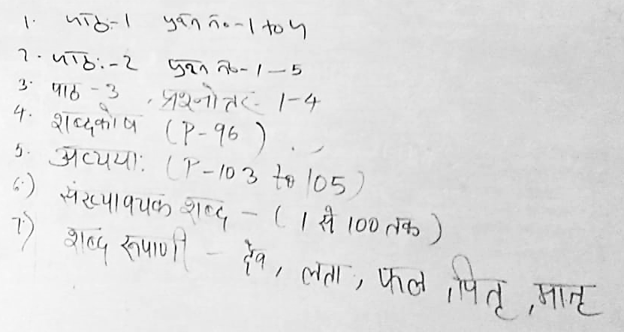**Subject – Sanskrit**