

**RPPS BOKARO**

**Set- A**

**Summer Holiday Homework (Session 2025-26)**

**Class – LKG \*\*\*\*\*\*\*\*\*\*\*\*\*\*\*\*\*\*\*\*\*\*\*\*\*\*\*\*\*\*\*\*\*\*\*\*\*\*\*\*\*\*\*\*\*\*\*\*\*\*\*\*\*\*\*\*\*\*\*\*\*\*\*\*\*\*\*\*\*\*\***

**Subject – Math’s**

**1. Cut the 5 different types of shapes of colors chart paper and paste the big**

**chat paper. like this**

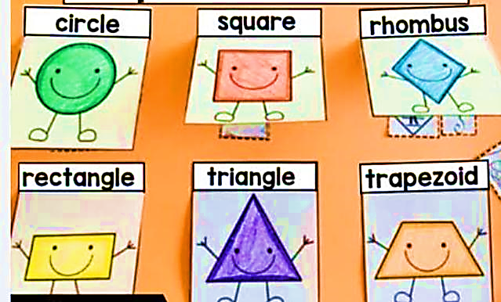

**2. Write the forward and backwards counting 1 to 10 in chat paper. Like this.**

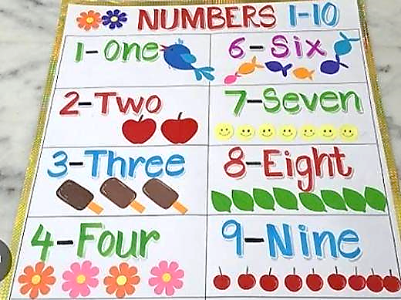

**Subject – English**

1. **Write the first letter of picture.**

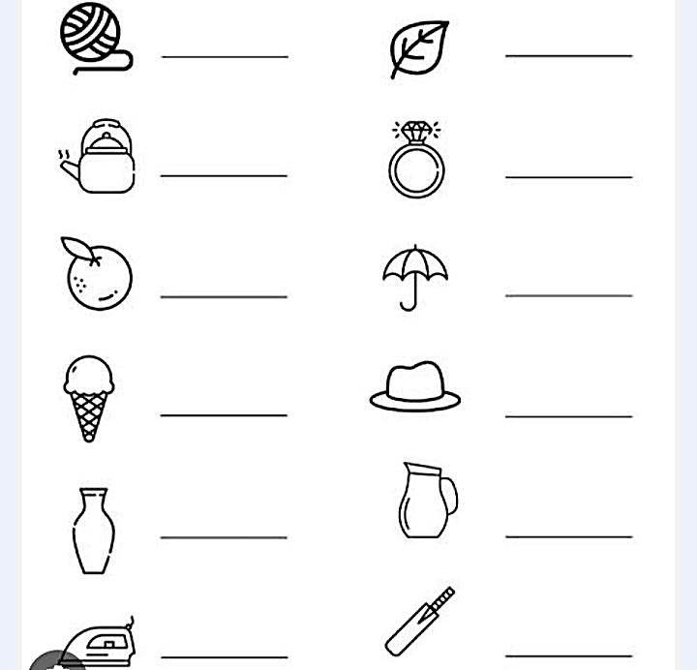

1. **Write the missing letter**

**A _____ C _____ D _____ F**

**G _____ I _____ K _____ M**

**N _____ P _____ R _____ T**

**U _____ W _____ Y _____**

1. **Write the alphabet A to Z in chat paper.**

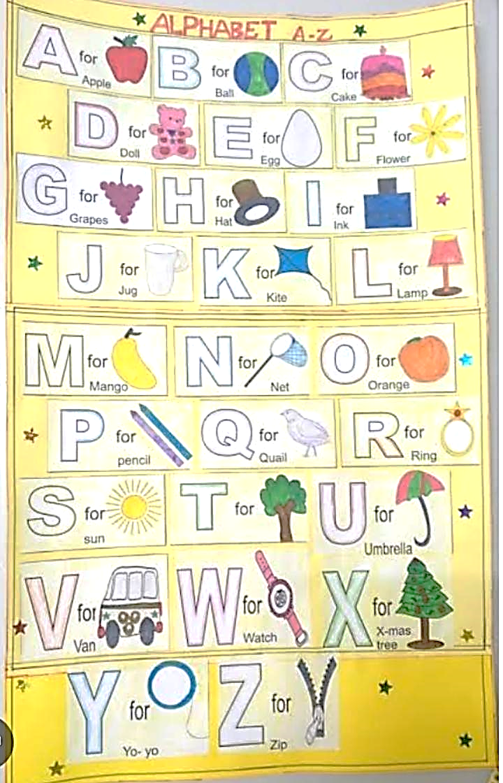

1. **Match the picture and their letter.**

** V**

**I**

**R**

**K**

**O**

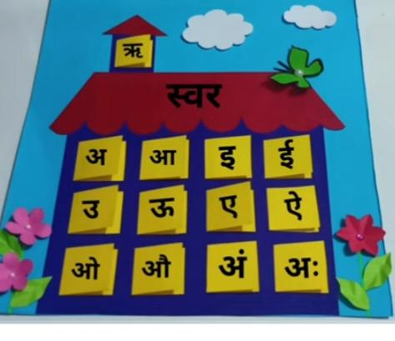**Subject- Hindi**

1. **चित्र के साथ अ से अः तक बनाये ( बडे रंगिन चाट पेपर पर)**
2. **चित्र देखकर सही अक्षर पर गोला करे ( कॉपी मे)**

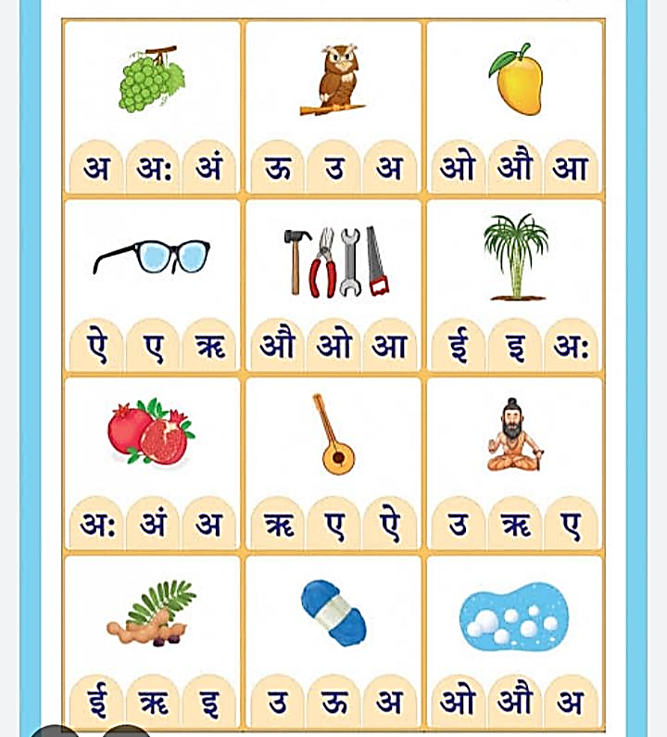

1. **दो वर्ण वाले शब्द लिखे (चाट पेपर पर)**

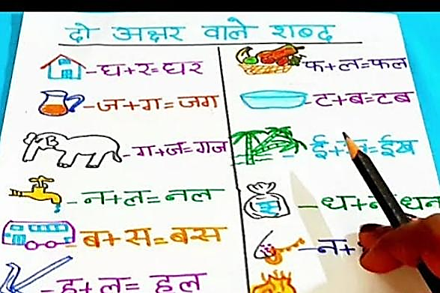

1. **क से ज्ञ तक लिखे । (चाट पेपर पर)**

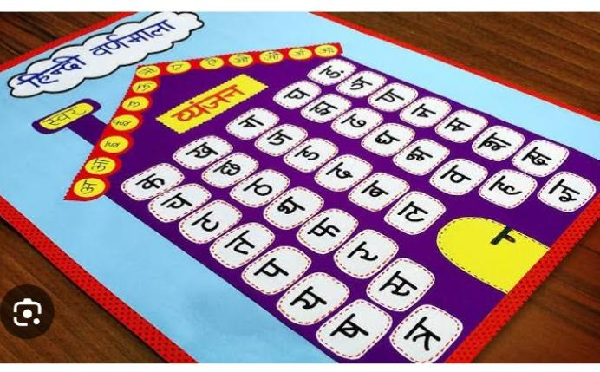

**\*\*\*\*\*\*\*\*\*\*\*\*\*\*\*\*\*\*\*\*\*\*\*\*\*\*\*\*\*\*\*\*\*\*\*\*\*\*\*\*\*\*\*\*\*\*\*\*\*\*\*\*\*\*\*\*\*\*\*\*\*\*\*\*\*\*\*\*\*\*\***

**Subject – G.K**

1. **Paste the 5 fruits in the scrap book.**
2. **Cut the chat paper of different faces and paste the scrap book**
3. **Paste the different vegetables picture with their name**
4. **Paste the picture of your family picture in your scrap book**