# FINAL EXAMINATION (2024-2025)

**LKG**

**Literacy**

# **Total Time: 3 hours Total Marks: 50**

General Instructions.

• All questions are compulsory.

• Marks of each question are indicated against it.

#### ****1. Write the First letter of the name of each picture (10x1=10)****

#### 

**2. Write the letter that comes after the given letters **(8x1=8)****

Q ___ ____ ____ ____ ____ _____ ____ Y ___

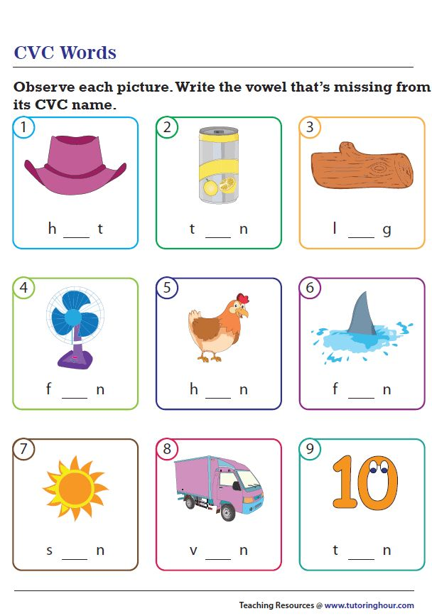****3. Observe each picture and write vowel that’s missing.** (9x1=9)**

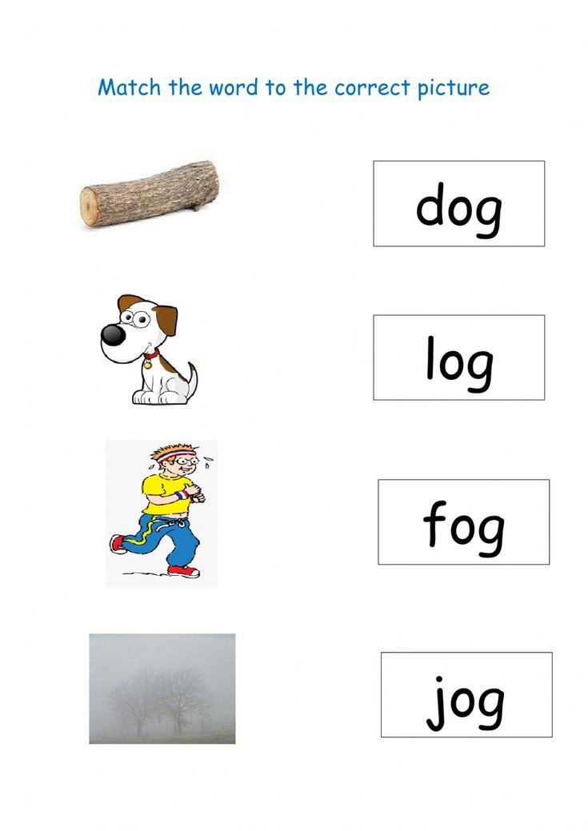**4. Match the word to the correct picture (4x1=4)**

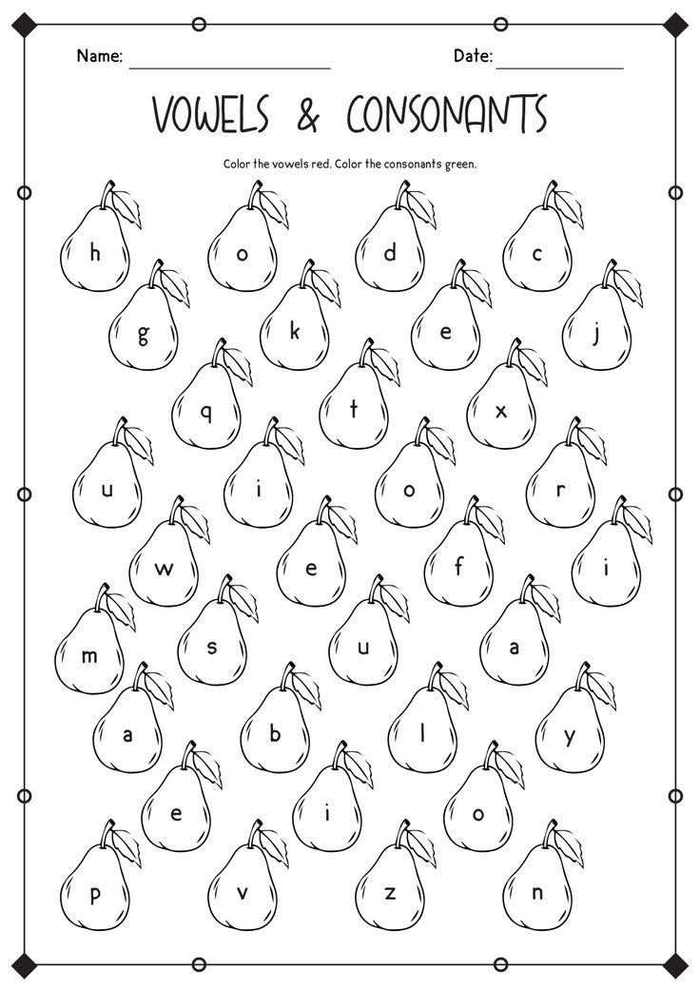**5. Color the vowels in BLUE (6)**

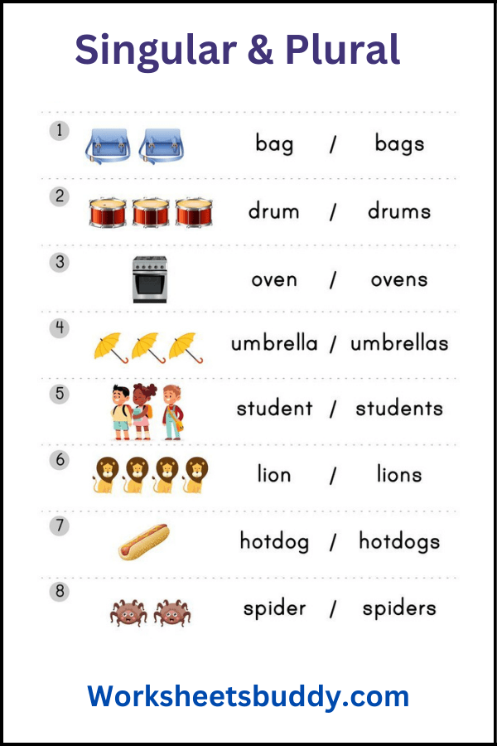**6. Observe each picture and Circle it’s one or many (8x1=8)**

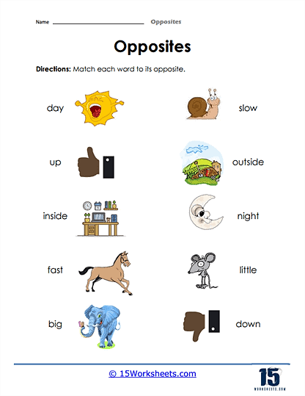**7. Match each word to its opposites (5x1=5)**