ROYAL PUBLIC SCHOOL
Holiday Homework & Assignment
Session - 2020-21
Class - 3
Subject- Sst
Write the capital of these states of India.
- Punjab
- Uttar pradesh
- Maharashtra
- Bihar
- Jharkhand
- West bengal
- Madhya pradesh
- Assam
- Kashmir
- Gujarat

Look at the following picture of the solar system and name the following.

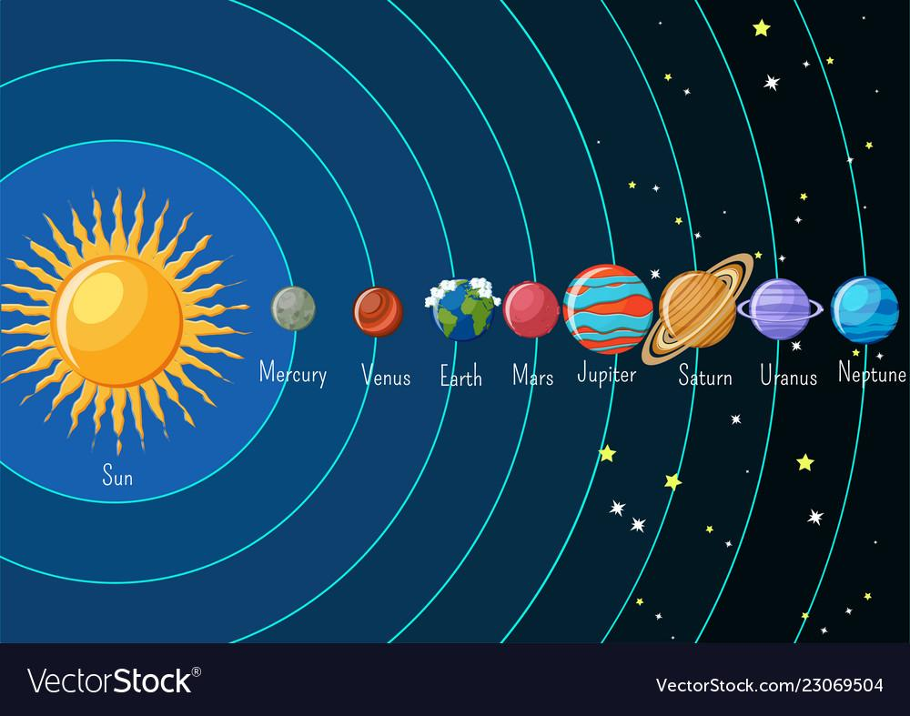
- Hottest planet from the sun.
- Closest planet from the sun.
- A planet with rings around it.
- Neighboring planets of uramas.
- Neighboring planets of the earth.
- Planet between earth & jupiter.

Make a poster to encourage the people not to pollote air, water and land.

Complete these pages.
Page no. - 63,62,65,67,70,.

