Royal public school
Session 2020-21
Summer Vacation Holiday Homework
Class-1.
Sub- Maths
(Make these things in holiday homework in notebook)
- Write the number name.
  - 8_________
  - 11________
  - 20_________
  - 14________
- Write the number before.
(a)_____21
(b)______32
(3) Write the number after
(a)49______
(b) 54______
(4) Fill in the blanks.
(a) 3+4=_____ (8,7)
(b)value of the colour digit 31______(30,1)
(c) write the biggest number_______(17,47,27)
(d) complete the pattern 19,21,23____(26,24,25)
(5) Add the following
(a)4+5=
(b)2+7+6 =____
(c) 12+0=______
(6) Write tables from 2 to 5.
(7)Make two pairs of clown’s cap using coloured paper.On each clown cap paste different number of bindis.then from each pair identify and tick the number plate of the cap having greater number of bindis.
(8) Make two number ladders.In one number ladder climb down from 30/21 and in another number ladder climb down from 50/41.(In scrap book)
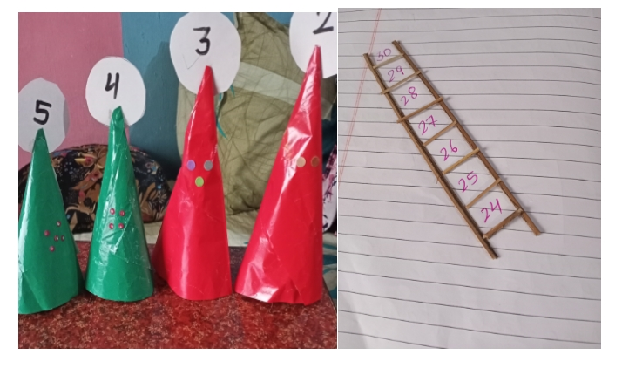

Do holiday homework in your book.
Class 1
Maths----
Page no 25,36,27,28,29

