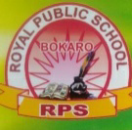
ROYAL PUBLIC SCHOOL (Session 2020-21)
SUMMER HOLIDAY HOMEWOR

CLASS - LKG
SUBJECT - G.K
________________________
- Learn and write 5 names.
( a) Domestic animals
( b ) Wild animals
( c ) Birds
( d ) Sea animals

2.Fill in the blanks

M __ THER

L __ ON

M __ NKEY

P __ RROT

F __ SH

3. Match the animal with their babies.

COW KID

DOG DUCKLING

LION PUPPY

DUCK CUB

GOAT CAL
4. Write the pictures name

🐈

🐍

👂

🐄

🐠

5. Circle the odd picture .

🐝 🐝. 🐌

🍆 🍅. 🍆

🍉 🍓 🍓

🌹 🌺 🌹

🌛 🌝 🌝

6. Match the pictures to word.

🐯 HAND

🐈 HEN

✋ CAT

🐟 TIGER

🐔 FISH

7. Activity work
*Learn ,draw or paste 5 parts of body and 5 insects pictures and write their name in scrap book
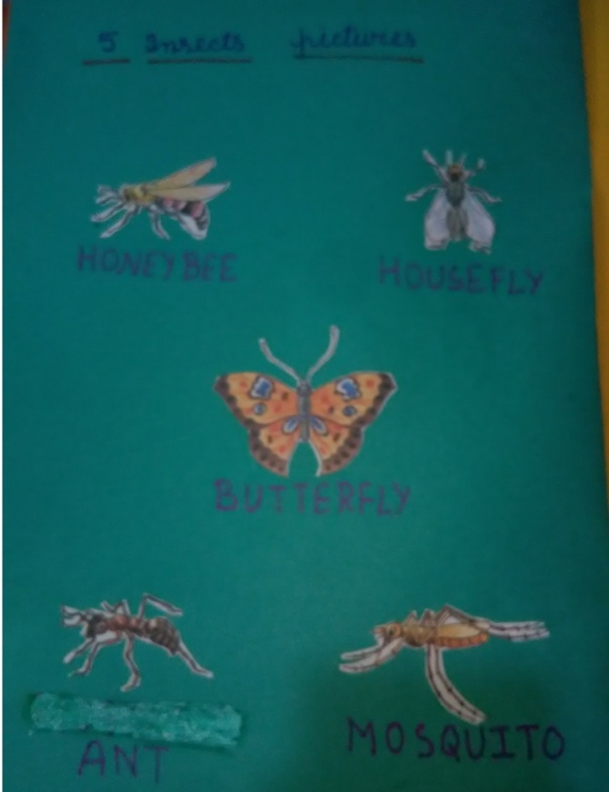
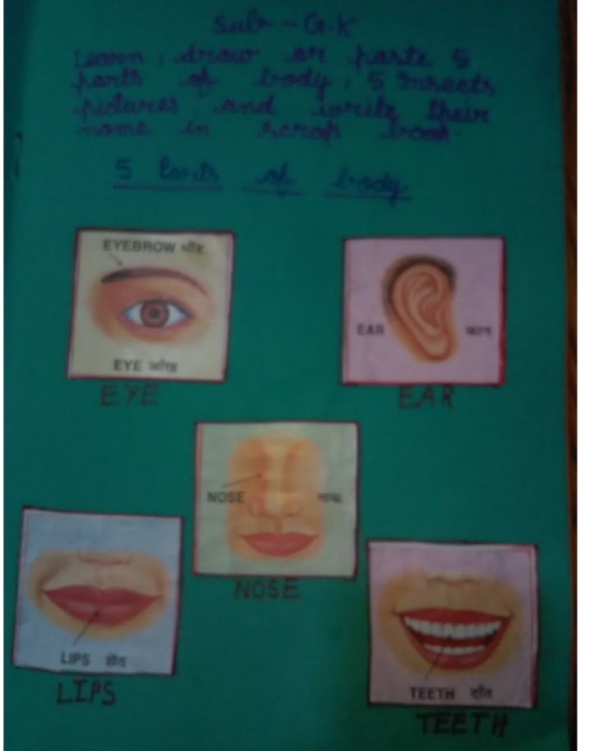

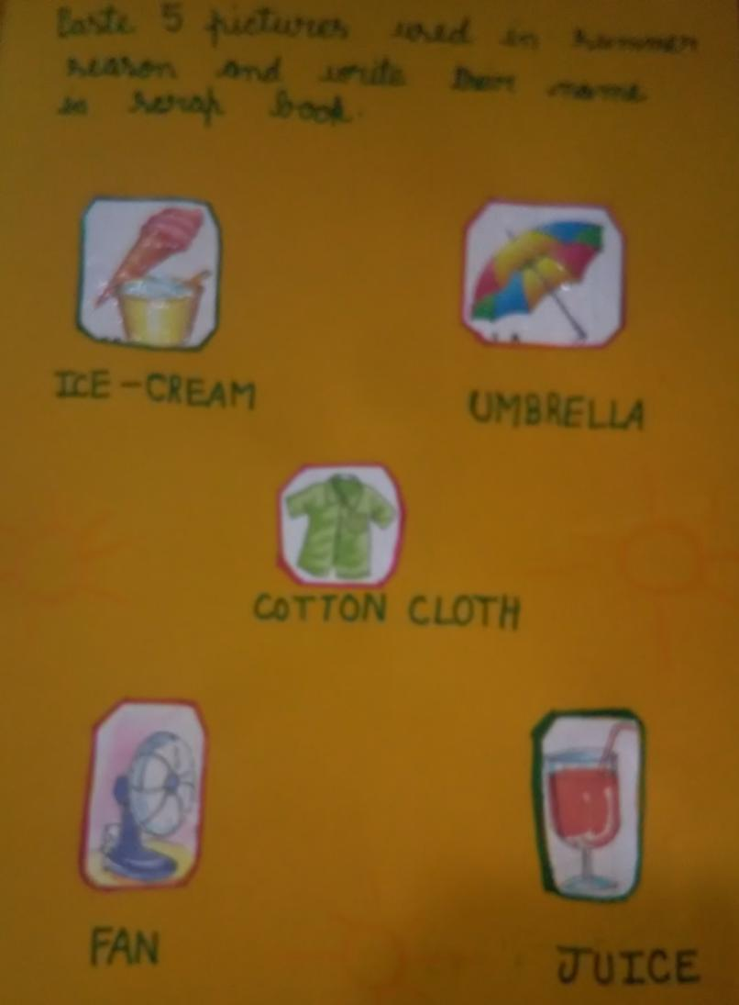
*Paste 5 pictures used in summer season and write their name in scrap book.

8. Do Holiday homework ( B )
book page no 59 to 63
and 77 to 81.

