Royal Public school
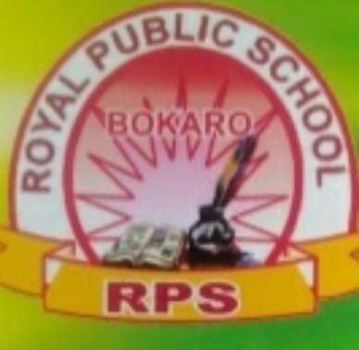
Summer Holidays homework 2020-21
Class : 1
Sub: English

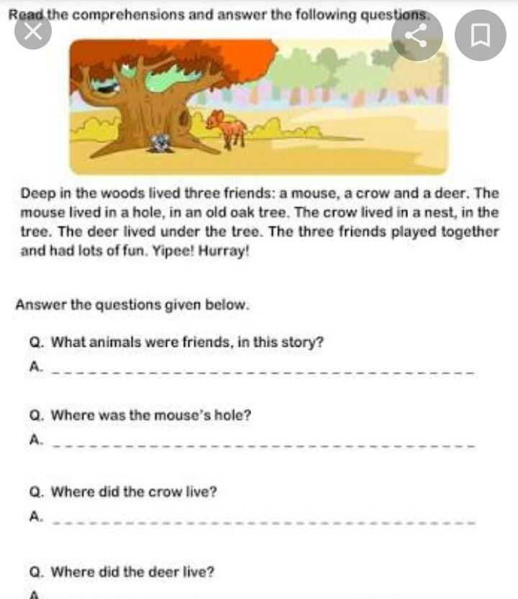

These all work do in new english notebook
2) See the picture and make more than 10 sentences
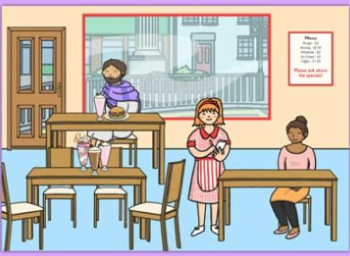

3) write one page handwriting everyday in english notebook and put the date.
4) write 5 sentences on each by pasting the picture .
Crow,Horse, Myself
Activity work
- Make a noun chart on chart paper or scrapbookok
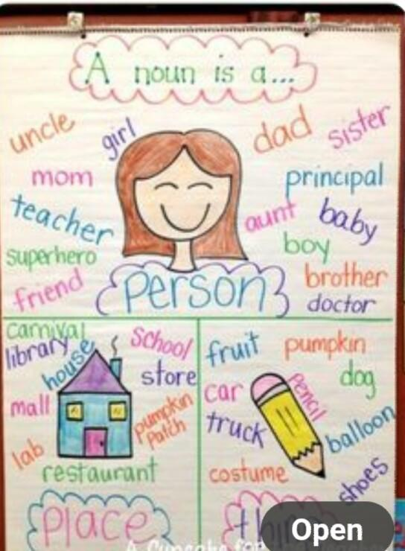

- Make a/an chart on chart paper or scrapbook
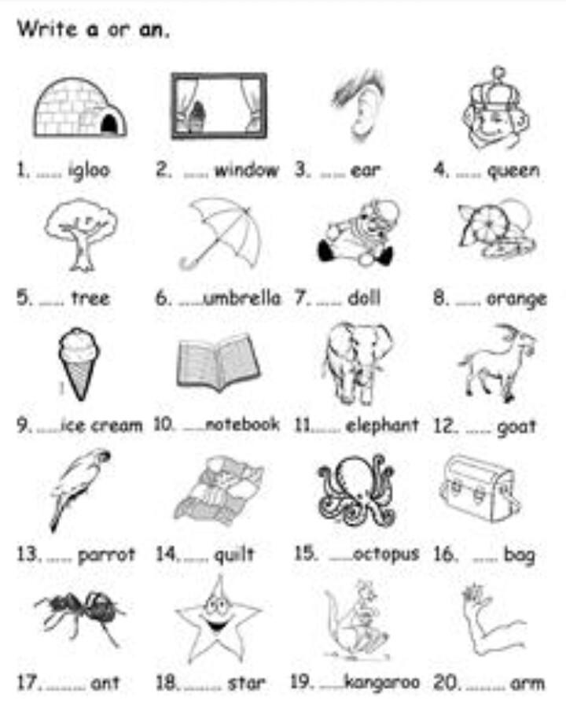

Holidays homework book work
Work sheet 1,2,3,4,5 (page no 3,4,5,6,7) do in book.
🌻 Happy Holidays children 🌻

