Royal Public School

Summer Holidays homework

Class :3

Sub: English

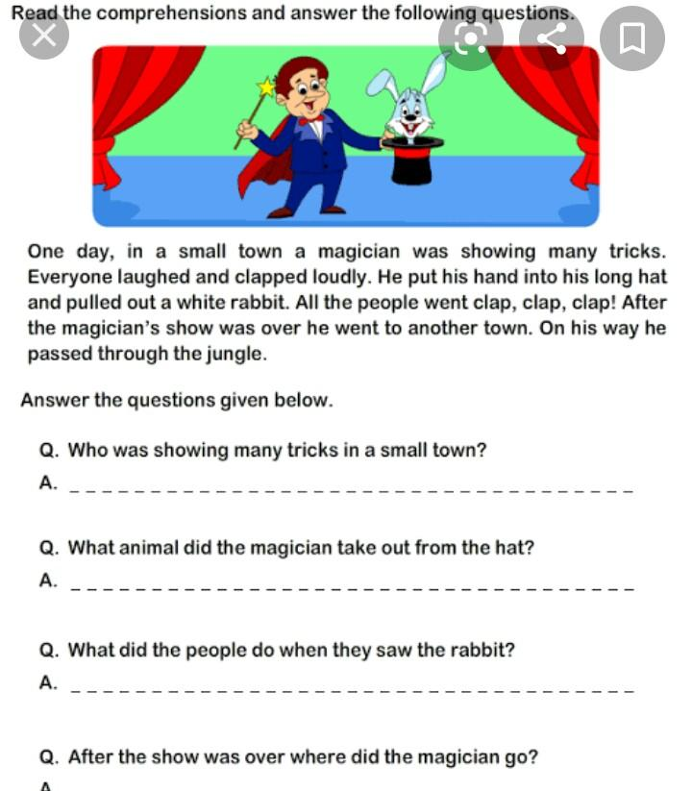**These all work do in new english notebook**

2)see the picture and make more than 10 sentences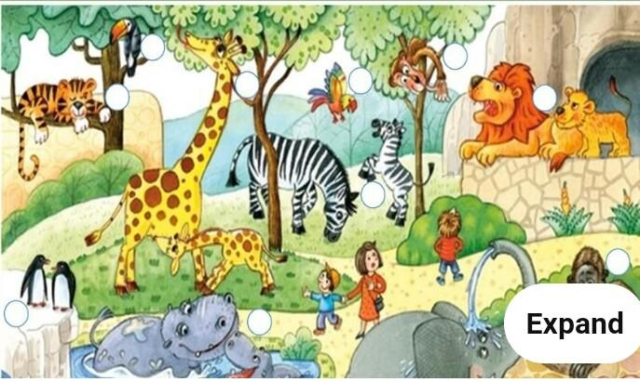

3) Write one page handwriting everyday in english notebook and put the date.

4) write 5 sentences on each one. by pasting or drawing the picture

Cow,Parrot,My school,My city,Tree

Activity work

1)Draw the flower on scrap book or chart paper and write down the word that come to your mind when you think of the word FRIENDSHIP (friendship forever) page no 1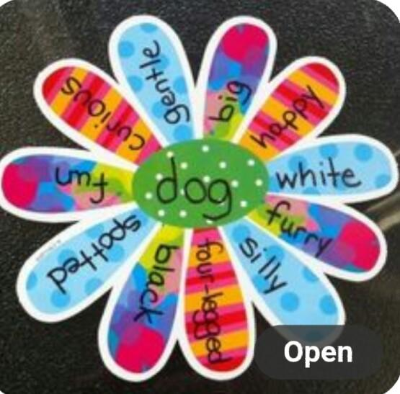

This is only example

2) Make a singular and plural chart on chart paper or scrapbook more than

10 picture paste or draw

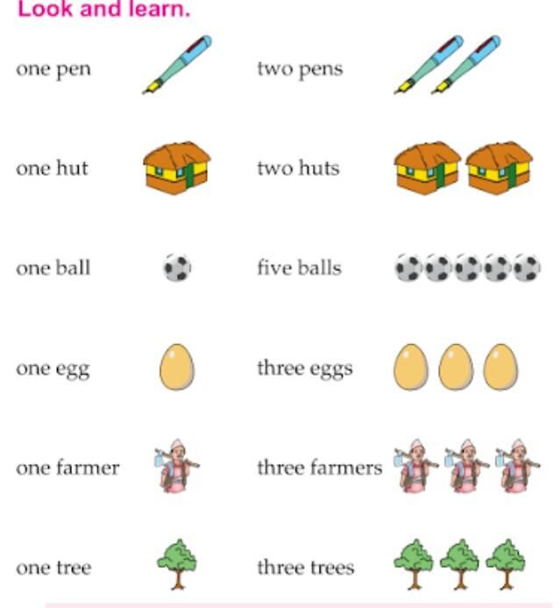

3) Make this common and proper noun chart on chart paper

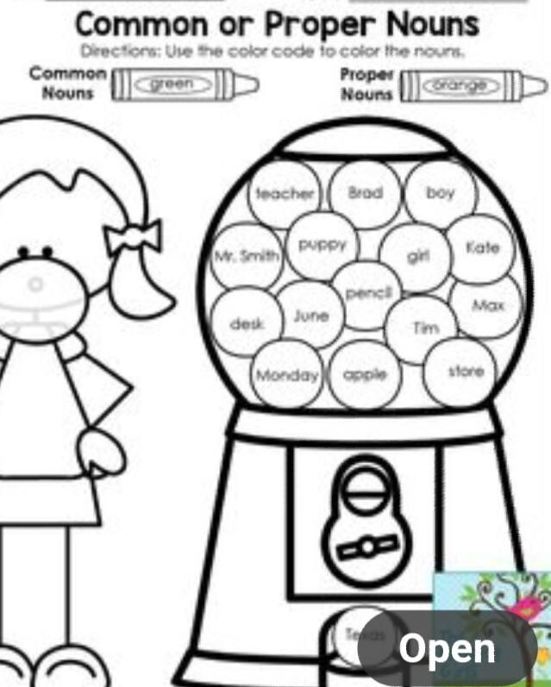

4) Make a / an chart on chart paper

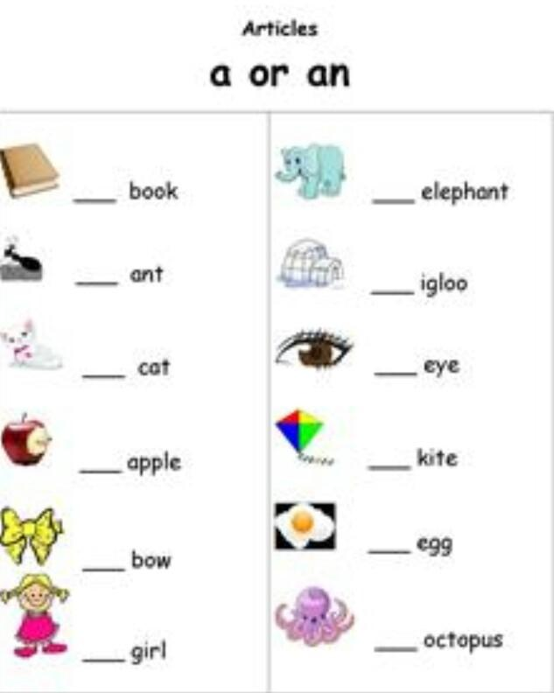

Holidays homework book work

Work sheet 1,2,3,4,5 (page no 3,4,5,6,7) do in book.

🌹 Happy Holidays children 🌹