Royal Public School
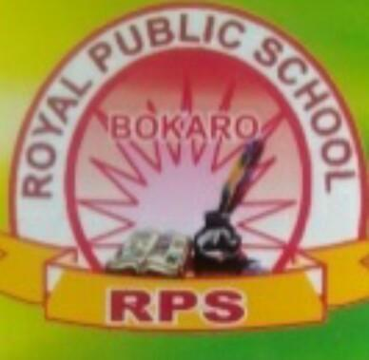
(2020-21)
Summer Holidays homework
Class. 2
Subj. English

Do these works in english notebook
Read the passage and give the answer
My school name is R.P.S. On the first day of school ,I was very happy. My school dress was new. My shoe was also new .My bag was new. I had new pencil. New eraser and new notebook .My lunch box is very beautiful. My water bottle is of myfavourite colour.Aman was my first friend Miss Puja was my class teacher.
She loved me very much .They welcomed me . All the children clapped and welcomed me .In this way,the first day of my school was very good.
1) Answer ty following questions
- What is the name of school?
- Who is your class teacher?
2) Fill in the blanks
- I was very _______.
- ____ was my first friend.
- All the children ____ and _____me.
3), Make the sentence
- New::
- Colour::
- Good::
2)Draw or Paste more than 20 pictures and use a / an
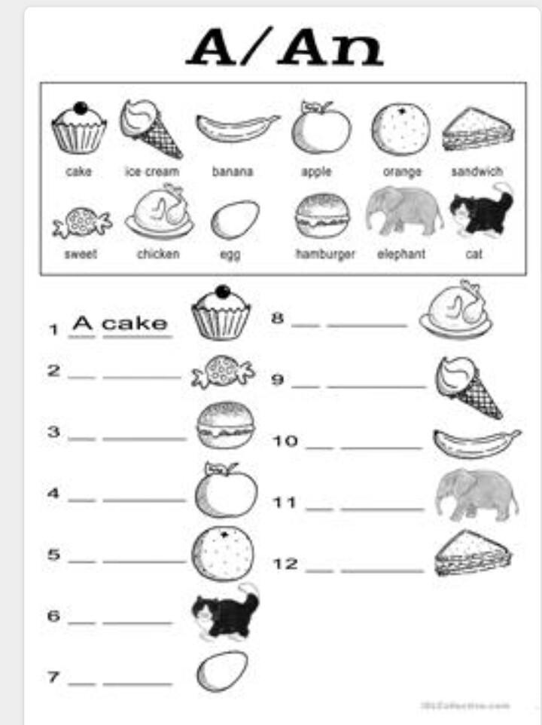
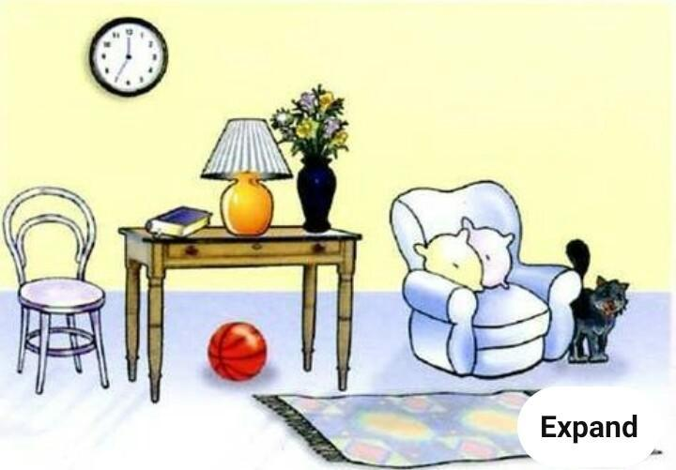
3) See the picture and make more than 10 sentences

4) Write one page handwriting everyday in english notebook and put the date.
Activity work
1) you have to paste the pencil
peel with your photo and write common and proper noun and make a beautiful project
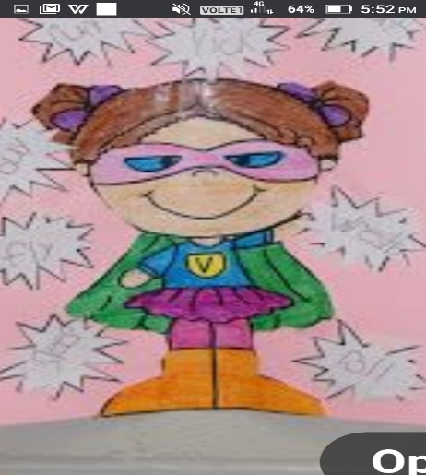

2) Make a proper and common noun chart on chart paper and decorate it

.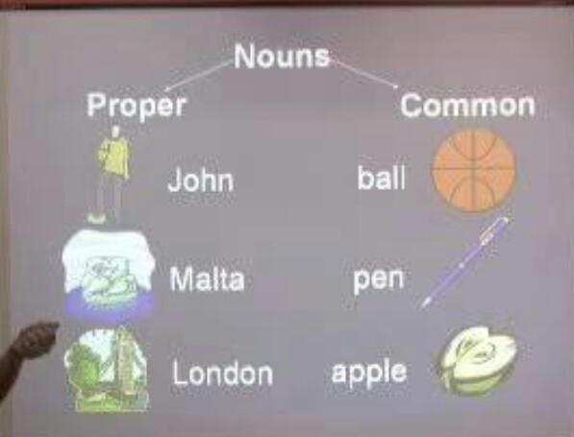

3) Draw the picture of clouds and write the rhymes clouds in four size chart paper (page no 19 )
Holidays homework book work
Work sheet 1,2,3,4,5,6( page no 3,4,5,6,7,8.these work do in book

