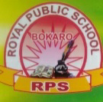
ROYAL PUBLIC SCHOOL (Session 2020-21)
SUMMER HOLIDAY HOMEWORK

Class - Nursery
Subject – English
________________________
- Write | ,\ , / , __ , L, H, I, and C all in different pages. (One page each)
- Match the same letter.
L I

T C

H L

C T

I H
- Write the first letter.
📺 ___
🎂 ___
🏠 ___
🍦 ___
🌿 ___
- Colour the picture.

👕

- Match the letter to pictures-
🔨 T

🔒 C

🚗 H

🐯 L

- Find the way:-

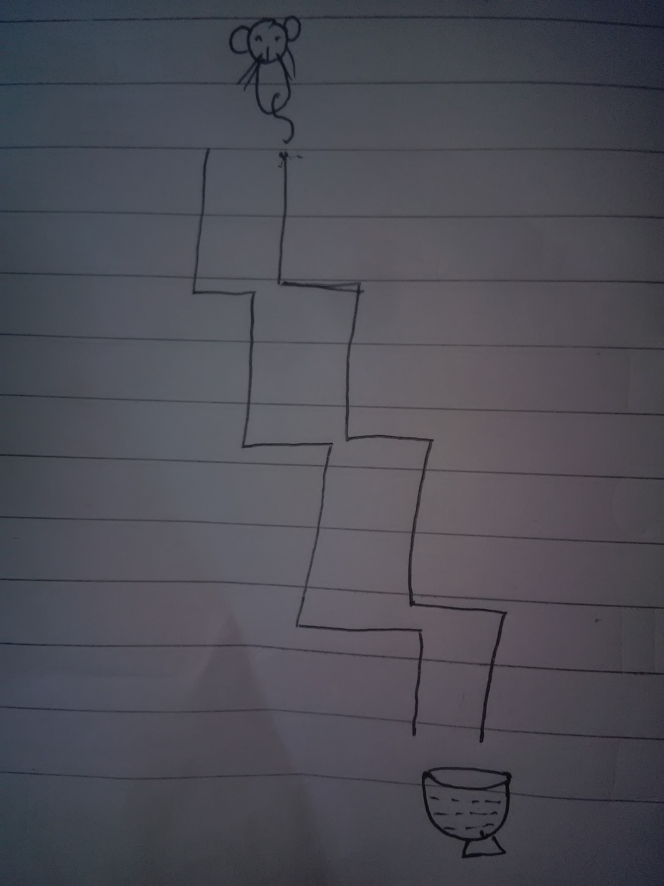

- Join the dots :
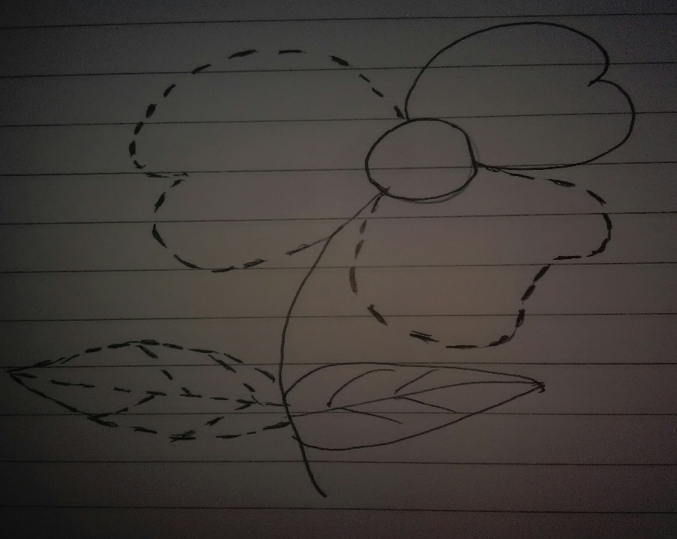

- Rhymes book - Learn the rhymes "Twinkle - Twinkle and Early to bed" with action.
9. Activity work
- Draw the standing line and zig - zag line in scrap book.
- Paste 3 pictures starting with letter T, H, I and C in scrap book.
10. Do Holiday homework - (A) book Page no - 2 to 6

