ROYAL PUBLIC SCHOOL
Holiday Homework & Assignment
Session - 2020-21
Class - 1.
Subject - Evs

1.Give one word answer for the following..
a. An animal that give us wool __
- An which live in forests. __
- Animal that have wings to fly and lay eggs. ___
- Animals with scales on their body. ___
- Animal that live with us like a family member.

2.Write the name of each parts of the body shown below in the blank boxes. :
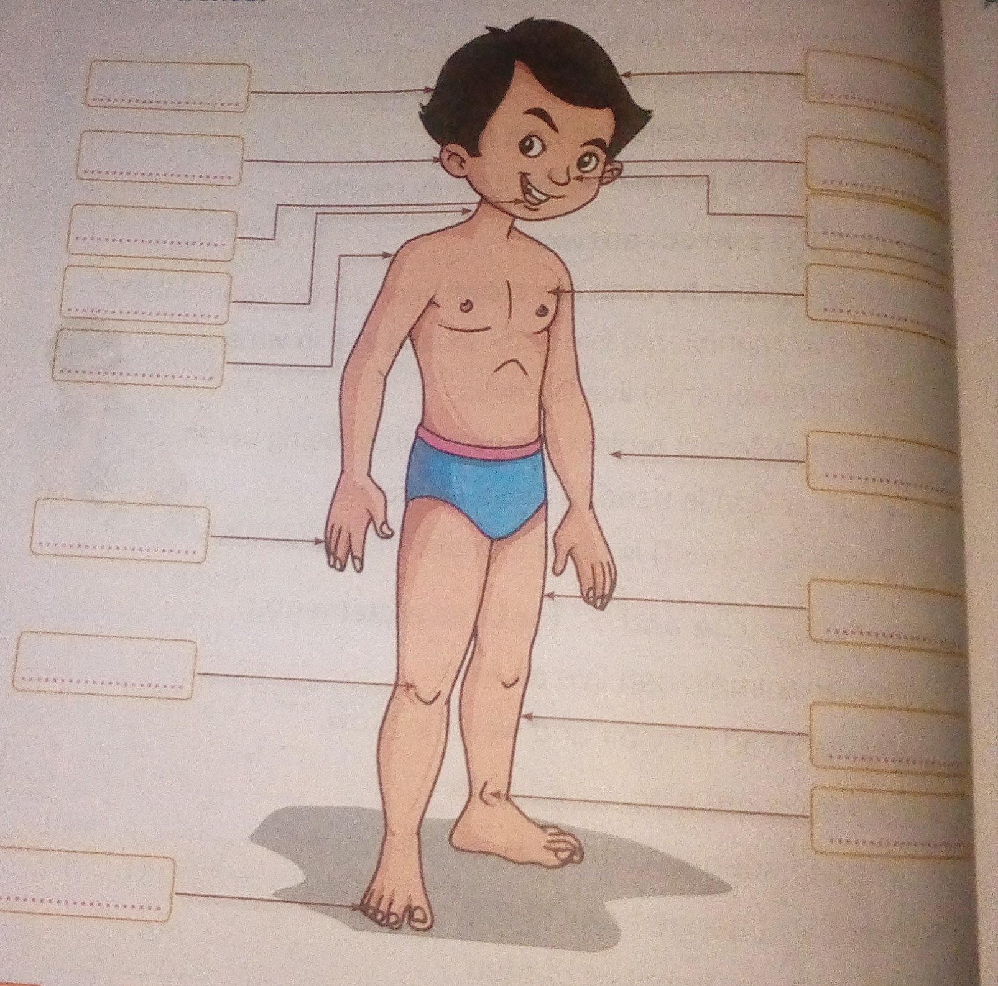

3. Make a family tree, paste pictures of family member in scrap book..

4. Make.model of a human body
(EVS book page no. 21).

5. Complete these pages..
Page no. 45,47,48,50,53.
In the holiday homework worksheet..

