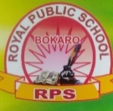
ROYAL PUBLIC SCHOOL (Session 2020-21)
SUMMER HOLIDAY HOME WORK
Class -4
Subject – Computer

Instruction about this homework
● Make these things in your computer notebook with question answer both.
● In front page should be mention your name, roll number, class and subject also.
● Mention everything in a proper way with date.
● When School will open then bring this copy with yourself for checking.
● Activities should be done in a chart paper.
● Remember all these things.

1) One Word Answer :-
( Name the options used for the following)
a) To delete a file or folder. .......................
b) To duplicate a file or folder. .......................
c) To change the name of file or folder. ......................
d) To restore the delete file or folder. .......................

( Write down the shortcut key of these options)
e) ............... is shortcut for copying text.
f) ............... is shortcut to cut the selected text.
g) ............... command is used to replace a word in the document.
h) ................ is used to know more about word.
i) ............... tab includes the spelling and grammar commands.
j) ............... shortcut key is used to select the entire document.

2) Tick (✔) the correct answer:-
- ......... is the main memory of the computer.
- Hard disk ii) Primary memory iii) Tertiary memory
- The CPU is located on the ............ of a computer.
- Mother board ii) RAM iii) Hard disk
- Which of the following is not an operating system developed by Microsoft?
- Windows 7 ii) Mac OSX iii) Windows 1
- Which is a shortcut for copying text.
i) Ctrl + V ii) Ctrl + C iii) Ctrl+ P
e) Name the option that is used to create a duplicate of a file/ folder.
i) Copy ii) Rename iii) Paste
f) Option in the start menu is used to add and remove program
i) All programs ii) Control panel iii) Shutdown
g) Which tab will you click on the open a file?
i) Home ii) File iii) Insert
h) which of the following is not a way of selection?
i) Ctrl + z ii) Double click iii) Click and drag
i) The default colour of the text in word is........... .
i) yellow ii) Pink iii) Black
j) The default font size is.........
i) 11 pt ii) 10 pt iii) 9 pt

3) Write True or False.
a) A mouse is output device. .....
b) A printer is used to send text or pictures as input to the computer. ....
c) A sub – folder can not contain any other folder. .......
d) Thesaurus is used to know more about a word. .......
e) Making changes to a document in word is called formatting. ......
f) Centimetre is the default unit of measurement for font size. .......
g) You can align a text in six ways. .........
h) Word automatically checks for spelling and grammar mistakes. .......
i) Press the F5 redo / repeat an action in word. ........
j) We create a duplicate of a file or folder by renaming it. ........

4) Matching
a)Ctrl + Z i) A type of monitor
b)Desktop ii) Underline
c)Memory unit iii) Subscript
d)CRT iv) Undo
e)H₂O v) A first screen
f) U vi) MU

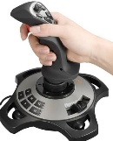
5) Identify these pictures:-
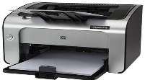
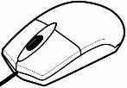
a) b) c) d) e)

............ ................. .................. ................. ................
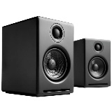
f) g)

............. ................

6) Give the answer of these questions:-
  - What is a computer?
  - What is taskbar?
c) How do you correct a spelling error while typing?
d) Which key or key combination we will use for these task?
Task Key or key combination
1)To search the word/ phrase
in a document -
2)Redo a Task -
e) What do you understand by Superscript?

7) Do this Activity work in a chart paper.
- Draw a mouse and label it's parts.
or
Draw two input device & Name them.

